EGYPTIAN LIMERICK
DUE 3 DEC

Using the list of Egyptian gods on the back of this sheet, write 3 limericks (a different god for each one) and I will pick the best one to grade. Remember a limerick has 5 lines. Lines 1, 2, and 5 rhyme with each other and are all longer. Lines 3 and 4 rhyme with each other and are shorter. A famous example below:

There once was a man from Nantucket
who kept all of his cash in a bucket.
But his daughter, named Nan,
ran away with a man,
and as for the bucket, Nantucket.

Scoring as follows:

  - 10pts – Limerick has correct rhyme scheme of 1:2:5 and 3:4.

  - 10pts – Lines 1, 2, and 5 are longer than 3 and 4.

  - 10pts – Limerick addresses a physical aspect of the Egyptian god in question.

  - 10pts – Limerick addresses a mythological aspect of the Egyptian god in question.

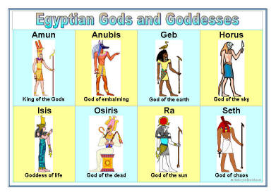

Amun – A creator god, patron deity of the city of Thebes, and the preeminent deity in Egypt.
Anubis – God of embalming and protector of the dead. Weighs heart against feather of truth in the after life.
Geb – Earth god. Father of Osiris.
Horus – Usually shown as a man with falcon’s head, linked with the sky, the sun, kingship, and protection. Son of Osiris and Isis who defeats Seth.
Isis – Wife of Osiris and mother of Horus, linked with funerary rites, motherhood, protection, and magic.
Osiris – God of death and resurrection who rules the underworld. Husband of Isis and father of Horus. Killed by Seth, resurrected by Isis and then fathered Horus who defeated Seth and took the throne back.
Ra – The foremost Egyptian sun god, involved in creation and the afterlife. Mythological ruler of the gods and father of every Egyptian king.
Seth – An ambivalent god, characterized by violence, chaos, and strength, connected with the desert. Mythological murderer of Osiris and enemy of Horus, but also a supporter of the king
Thoth – God of knowledge, writing and scribes. Records the results of the heart weighed against the feather of truth.

