Egypt Visual Project Rubric
DUE W/ Portfolio

Students will pick their topic from the list below and make a visual project along with an explanatory paragraph about:
- 3 Seasons of Ancient Egypt
- 3 Kingdoms of Ancient Egypt
- 3 gods from the Egyptian pantheon
The two options for the project are a 6 frame comic strip or a 6 slide PowerPoint presentation. Point scale as follows:

Comic (can use online creator like pixton.com)
  - 10pts – Cartoon composition (limited white space, more than 3 colors used, some degree of effort to make aesthetically pleasing)
  - 10pts – Cartoon displays accurate hieroglyphs somewhere in the story and are explained in the accompanying paragraph
  - 10pts – 6 frames total with at least one sentence in each frame
  - 10 pts – Historical context is accurate and is explained in an accompanying paragraph
PowerPoint
  - 10pts – Each slide has a visual representation (photo, poster, graph)
  - 10pts – PowerPoint displays accurate hieroglyphs somewhere in the slideshow that are explained in the accompanying paragraph (can be hand drawn)
  - 10pts – 6 slides total with at least one map and an explanation of why you chose the map in the accompanying paragraph
  - 10pts – Each slide possesses at least 1 historical fact related to your topic (explain why you included any facts that are not very clearly related to your topic in your accompanying paragraph)
You will not be graded specifically on the accompanying paragraph, but it is your chance to explain your work and make sure that I understand specifically what your intent was with the project.
Good luck and have fun!
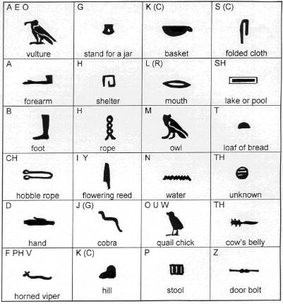

This is just to help you get started. Remember there are almost 700 additional symbols you can utilize as well.

