America HAIKU
DUE 18SEP

Using the region map on the board (and website), your text book, and Google images, write three haikus. Each haiku will be about a distinct region of America. For each region you will include a picture copied from Google images. Remember a haiku has 3 lines with 5 syllables in the first and third lines and 7 syllables in the second line, creating a 5-7-5 pattern. It does not have to rhyme. An example below:

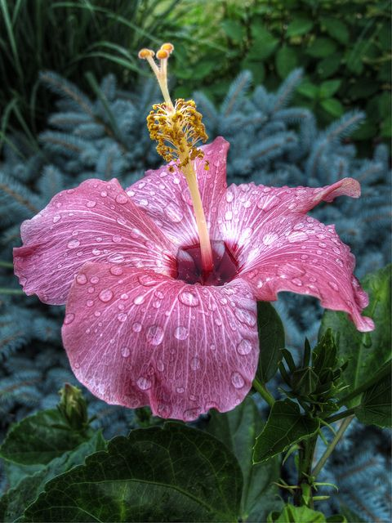

In the twilight rain
these brilliant-hued hibiscus -
A lovely sunset

-Basho

You will be scored on the best of the three haiku written. I will star that haiku to make clear which one I am scoring. Scoring as follows:

  - 10pts – Haiku has correct syllable scheme of 5-7-5.

  - 10pts – Picture pasted reflects your haiku.

  - 10pts – At least half the words in the haiku are nouns, adjectives, or verbs.

  - 10pts – Haiku has some connection to nature, relevant to the region of America that it is written for.

